MAG - 36 Command Philosophy
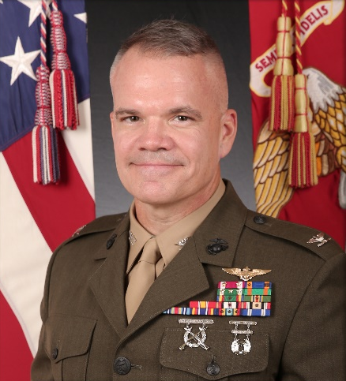
Our Mission in Marine Aircraft Group-36 is to “Support the Marine Air Ground Task Force (MAGTF) with combat ready expeditionary assault support aircraft and when directed, plan and conduct aviation operations as a Marine Expeditionary Brigade-level Aviation Combat Element.”

The Marine Corps is a no-fail organization, and MAG-36 will always be ready to accomplish the mission. As our 31st Commandant, General Krulak said, “We owe our country a certain force in an uncertain world.” The only way to succeed is to invest in our Marines and our families both on and off the flight line. Balancing the demands of operational excellence and the wellbeing of the people who make it possible, is where we will thrive.
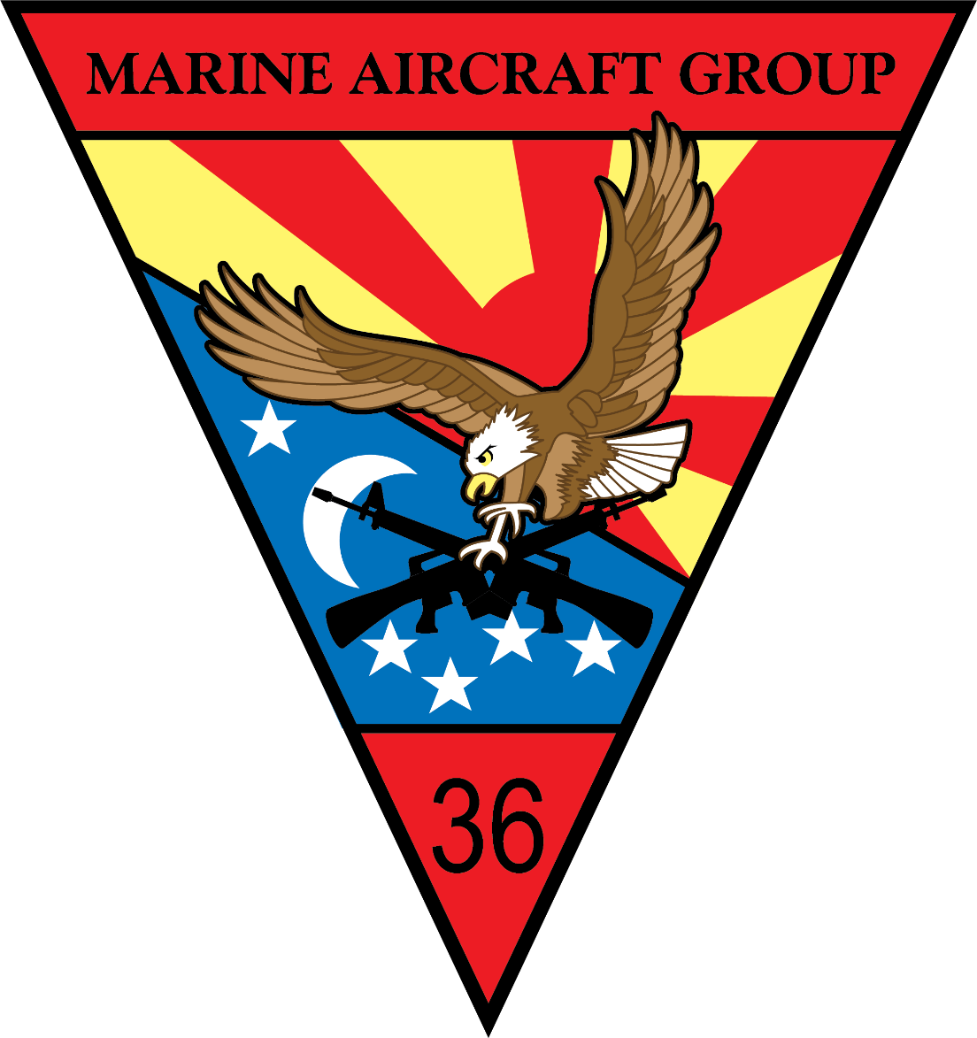
I ask one thing of myself, and I ask the same from each of you:

“Be Professional. Always!”

- Honor, Courage, Commitment. This is the soul of the Marine Corps. We must be resolute in our core values. Do the right thing, the right way – all the time. Be Consistent! Take your job and your responsibilities seriously; others are depending on you to accomplish the mission. Bet the Marine that others count on.

- Accountability. Be personally accountable for your actions and the actions of your Marines. Treat every piece of equipment as if it cannot be replaced. You and your family cannot be replaced either. Be accountable at work and at home.

- Respect Your Fellow Marines. This starts in the mirror. Respect yourself. Be mindful of yourself and others whether its physically, mentally, or spiritually. Respect is given, just as it is earned. Trust that every Marine is striving to do their job the best they can. Meet them where they are and help them be their best.

MAG-36 End State:
Be a better Marine when you leave.
Leave the Group better than you found it.

Colonel Lee W. Hemming
Commanding Officer, Marine Aircraft Group - 36

