Marine Aircraft Group – 36
Unit, Personal, and Family Readiness Policy


The Marine Corps’ most valuable asset is the individual Marine and his or her family. The success of MAG-36 in our assigned mission is inextricably linked to the well-being and resiliency of the individual Marine and their family. Family readiness is the ability of the individual Marine or Sailor and their family to balance the challenges of military service and family commitments.

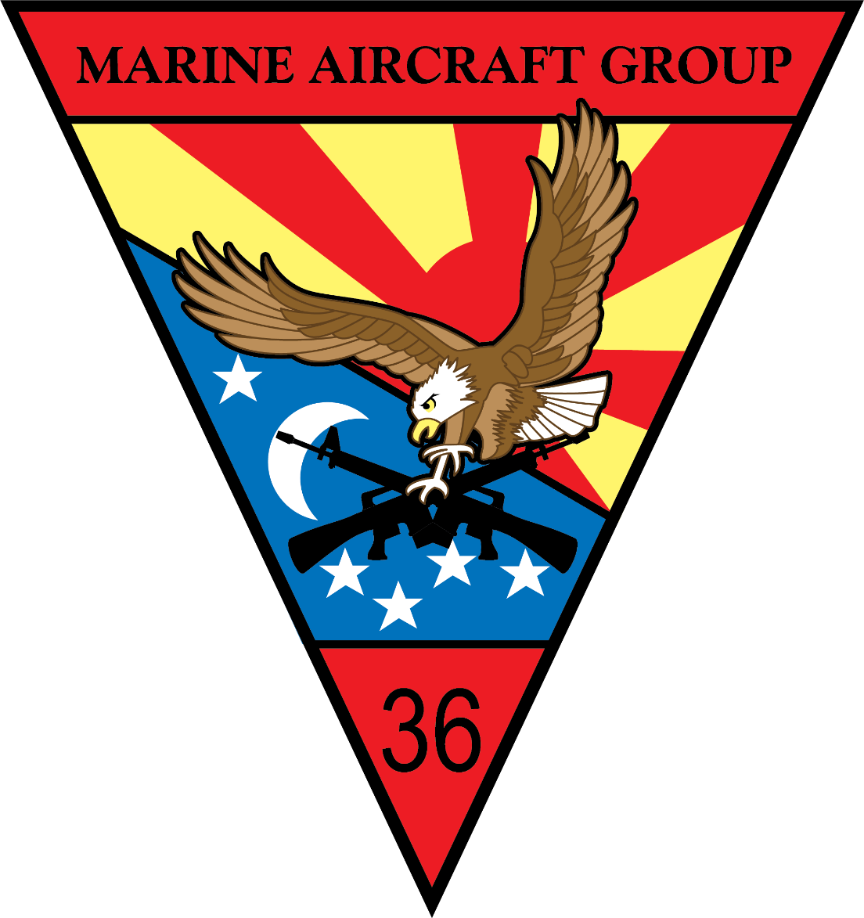
Honor – Courage – Commitment. Our core values aren’t just for the Corps. Apply these principles to every aspect of your life and across your “Three Families:” 1. Born into, 2. Married into, 3. Assigned.

- Honor. We honor people by showing them our attention, acceptance and respect.
- Courage. We demonstrate courage by offering people protection, safety and security.
- Commitment. We show commitment by giving people our time, support and care.

Preparation. It is our responsibility to ensure all members of the MAG-36 family understand the additional responsibilities they will be accountable for when we deploy. An abundance of community and family resources are accessible to our Marines and Sailors, and we must ensure our families know what support is available to them.

Balance. Balanced excellence applies to our professional lives as well as our personal and family lives. Time is a commodity. Time spent with our families is precious, yet fleeting, when matched with the demands of a military lifestyle. When you are not on duty, focus on your family. Invest in your relationships and responsibilities as a spouse, parent, sibling, and child. In doing so, you will demonstrate and exemplify our core values to your family and in turn, they will be better prepared to support our mission as warfighters.

Colonel Lee W. Hemming
Commanding Officer, Marine Aircraft Group - 36

