Marine Aircraft Group – 36
Safety Policy
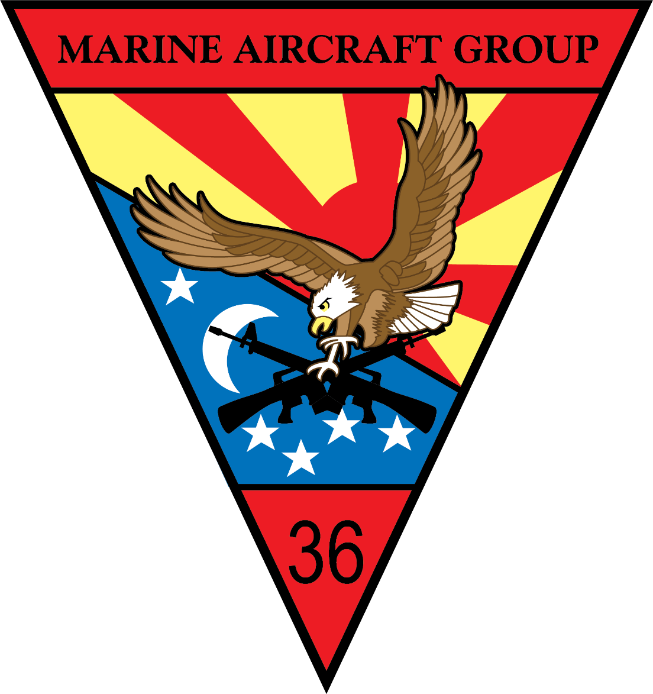
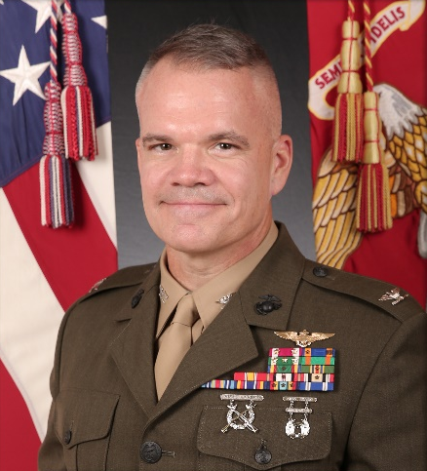
The Marines, Sailors, Civilians of MAG-36 are our most precious asset. Without you, we cannot conduct our mission. The death or serious injury of a member of MAG-36 or loss of an aircraft or equipment will significantly impact our combat readiness. We will maintain a safe and efficient work environment through the application of professional excellence, discipline, solid decision making, and risk management. Identify the things that can hurt you and mitigate them through common sense and controls. MAG-36 will execute by the book and per standing orders and regulations. Whether this is maintaining or flying aircraft, riding motorcycles, driving vehicles, or executing liberty, we will assume no unnecessary risk. We will accept risk only when the benefits clearly outweigh the risks. Everyone is a safety officer. If you witness something unsafe, correct or report it immediately.
- Safety is not an add-on to the process; it is inherent in everything we do.

- Aircraft maintenance & flight operations are dangerous: NEVER forget lives & aircraft depend on careful flight planning, correct maintenance actions, and sound flight discipline.

- MAG-36 operates several pieces of complex ground equipment that demand the same discipline and rigorous planning as flight operations to ensure safe and effective operation. It is easy to fall into the complacency of the daily grind. The effort you put into the little things matters each and every day. You will never know how many mishaps you prevent, only the ones that you don't.

- The MCAS Futenma flight line and our facilities will be undergoing significant renovations over the coming years that will impact maintenance and flight operations. Expect inconvenience and frustration, but never settle for less than the safe and professional execution of our mission.

Colonel Lee W. Hemming
Commanding Officer, Marine Aircraft Group - 36

