Marine Aircraft Group – 36
Sexual Assault Policy

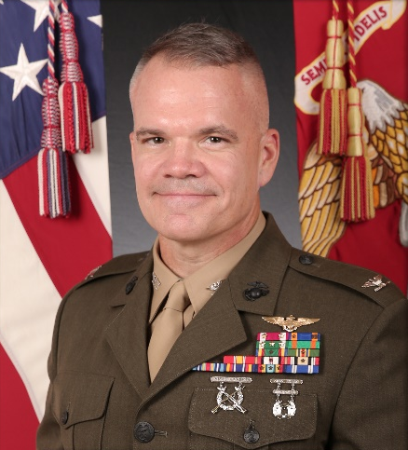
Sexual assault is a crime and incompatible with Marine Corps core values. MAG-36 has ZERO TOLERANCE for sexual assault, and those who commit such acts will be held accountable. Each of us has a duty to protect the rights and freedoms of others through active BYSTANDER INTERVENTION, and I expect all MAG-36 commands to educate and create a climate that stresses the importance of respect, dignity, and decency. Each of us should recognize situations that may lead to sexual assault or sexual harassment, and we must take the intervention steps necessary to prevent all forms of sexual violence.
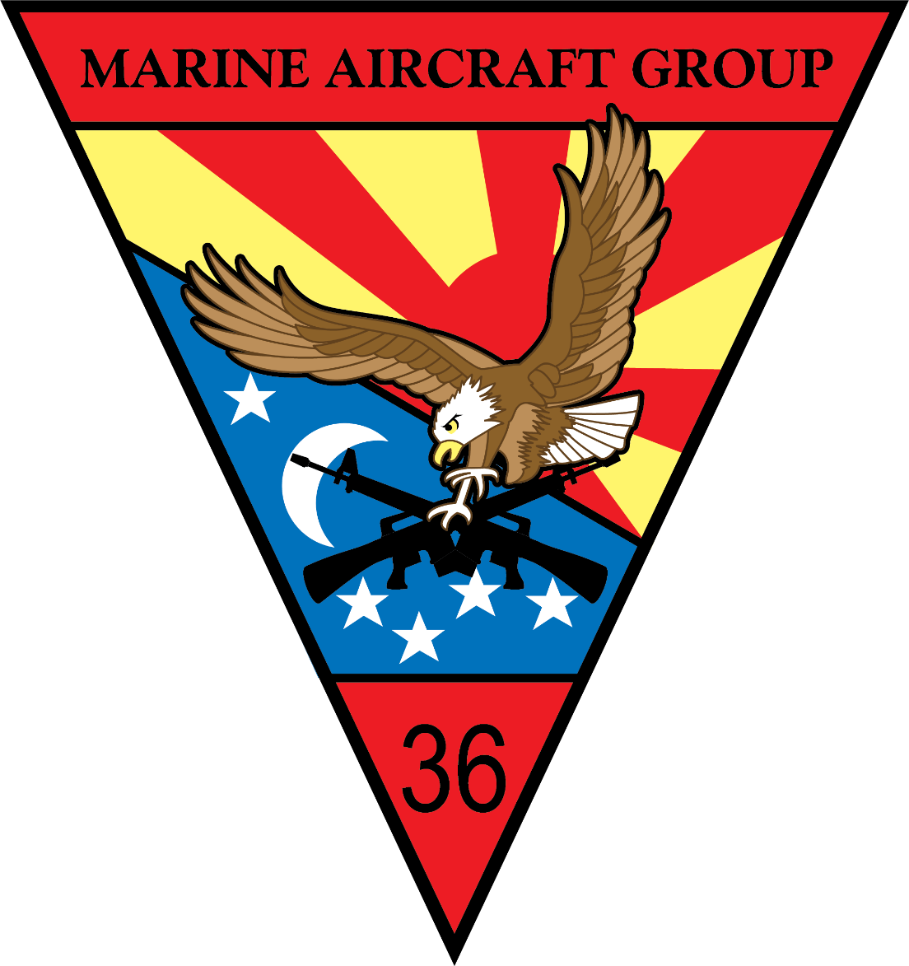
Sexual assault is defined as “intentional sexual contact characterized by the use of force, threats, intimidation, or abuse of authority, or when the victim does not or cannot consent.” DoDI 6495.02, Vol 2, and MCO 1752.5C provide governing guidance on the Sexual Assault Prevention and Response Program, and all MAG-36 personnel will become familiar with these references. Leadership, education, training, awareness, and EARLY intervention are the keys to eliminating behaviors that often lead to sexual assault and sexual harassment.

This command will ensure that a victim’s rights are always protected and that all sexual assault reporting options and services are provided. Leadership will ensure neither the victim nor the accused are ostracized during an investigation, and they will ensure every member knows who and how to contact their SAPR Victim Advocates (VA) or the MAG-36 Sexual Assault Response Coordinator (SARC). All victims will be treated with the sensitivity and respect they deserve.

For any reports of sexual assault, assistance is available 24/7 through any of the following methods:
- Squadron SAPR Victim VAs
- MAG-36 SARC Duty Cell: 070-7896-5267
- Okinawa 24/7 SAPR Support Line: 645-HOPE (4673); 098-970-4673
- NCIS: 645-0213
- Victims Legal Counsel: 645-4421; 098-970-4421
- MAG-36 Chaplain: 636-3016
- Camp Foster Naval Hospital ER: 646-7311; 098-970-7311
- Family Advocacy/Counseling: 645-2915; 098-970-2915
- DoD Safe Helpline: 1-877-955-5247; https://safehelpline.org/

Colonel Lee W. Hemming
Commanding Officer, Marine Aircraft Group - 36

